## D:\Dotnet\Material\DEVOPS\Agile & Scrum\Images\Software-development-models.PNG

## D:\Dotnet\Material\DEVOPS\Agile & Scrum\Images\Waterfall.PNG

## Waterfall Model best suited for

## Project requirements & objectives are clear, not ambiguous and very rarely changing

## Project is large, expensive & complicated, client expect the formal approaches

## Project’s cost is pre-defined, fixed-price

## Immediate implementation is not required

## What Is Agile Methodology?

* Agile is a Software development methodology is a practice that helps continuous iteration of development and testing in the SDLC process.
* Agile breaks the product into smaller builds.
* Agile software development is a set of principles for software development in which requirements and solutions evolve through collaboration between self-organizing, cross-functional teams.
* Agile methodology is a practice that promotes continuous iteration of development and testing throughout the software development lifecycle of the project.

## Benefits of Agile Methodology

* **Faster**. Speed is one of the biggest benefits of Agile Methodology. A faster software development life cycle means less time between paying and getting paid. That, in turn, means a more profitable business.
* **Increased customer satisfaction**. With Agile, customers don’t wait for months or years, only to get exactly what they didn’t want. Instead, they get iterations of something very close to what they want, very fast. The system adjusts quickly to refine the successful customer solution, adapting as it goes to changes in the overall environment.
* **Values employees**. Employees whose ideas are valued are vastly more productive than those who are ordered to follow a set of rules. The Agile Methodology respects employees by giving them the goal, then trusting them to reach it. Since they’re the ones with their hands on the controls and the ones who see the obstacles that crop up every day, employees are in the best position to respond to challenges and meet the goals at hand.
* **Eliminates rework.**By involving the customer at more than just the phases of requirements and delivery, the project remains on-task and in-tune with customer needs at every step. This means less backtracking and less “out on a limb” time between the time we do the work and the time the customer suggests revisions.

**Scrum**

* Scrum is a framework based on agile principles.
* Scrum is a widely used framework for agile.
* Scrum is a framework that implements Agile.
* Scrum is a lightweight framework and simple to understand.
* Scrum is a framework for developing and sustaining complex products.
* Scrum is a better way of building products or Applications.
* Scrum is used every where
* Scrum is a team based collaborative approach
* Scrum is iteratel and incremental development.

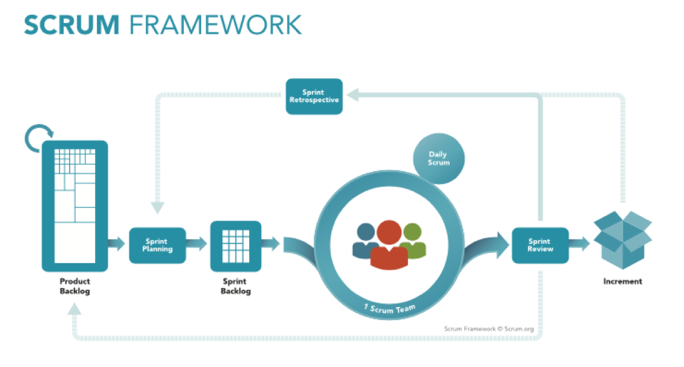

The Scrum framework consists of Scrum Teams and their associated roles, events, artifacts, and rules.

**Scrum - Roles**

The scrum framework consists of three core roles.

1.Scrum Maser

2.Product Owner

3.Development/Scrum Team

## Scrum Master

The Scrum Master is the keeper or servant leader of the scrum Team. He/she is responsible for-

* making the process run smoothly
* removing obstacles that impact productivity
* organizing and facilitating the critical meetings
* Addressing team dynamics
* Establishing an Environment where the team can be effective
* Ensuring a good relationship between the team and product owner as well as others outside the team.
* Protecting the team from outside interruptions and distractions.

**Role of Scrum Master**

**The Scrum Master serves the Product Owner in several ways, including:**

* Finding techniques for effective Product Backlog management;
* Helping the Scrum Team understand the need for clear and concise Product Backlog items;
* Understanding product planning in an empirical environment;
* Ensuring the Product Owner knows how to arrange the Product Backlog to maximize value;
* Understanding and practicing agility; and,
* Facilitating Scrum events as requested or needed.
* Scrum Master Service to the Development Team

**The Scrum Master serves the Development Team in several ways, including:**

* Coaching the Development Team in self-organization and cross-functionality;
* Helping the Development Team to create high-value products;
* Removing impediments to the Development Team’s progress;
* Facilitating Scrum events as requested or needed; and,
* Coaching the Development Team in organizational environments in which Scrum is not yet fully adopted and understood.

**Scrum Master Service to the Organization**

* The Scrum Master serves the organization in several ways, including:
* Leading and coaching the organization in its Scrum adoption;
* Planning Scrum implementations within the organization;
* Helping employees and stakeholders understand and enact Scrum and empirical product development;
* Causing change that increases the productivity of the Scrum Team; and,
* Working with other Scrum Masters to increase the effectiveness of the application of Scrum in the organization.

## Product Owner

## The Product Owner is responsible for maximizing the value of the product and the work of the Development Team. How this is done may vary widely across organizations, Scrum Teams, and individuals.

## The Product Owner is the sole person responsible for managing the Product Backlog.

## The Development/Scrum Team

* The Scrum Team is self-organizing and cross-functional.
* The team comprises of analysts, designers, developers, testers, etc. as appropriate and as relevant to the project.
* The Scrum team responsible for coming to work.
* The scrum team works together closely, on a daily basis, to ensure the smooth flow of information and the quick resolution of issues.
* The scrum team delivers product iteratively and incrementally.
* Ideal core team size 7

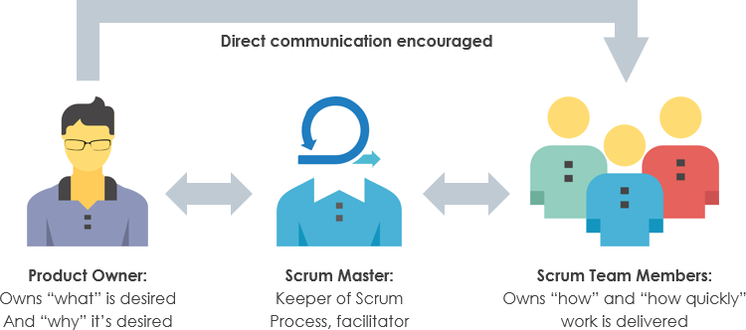

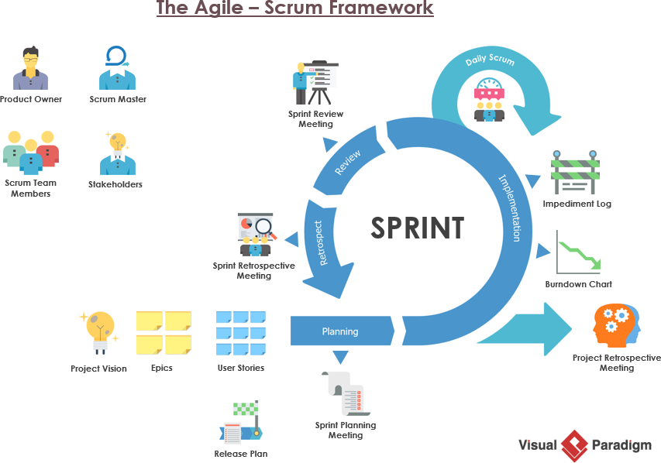

**Sprint**

* Sprint is a heart of scrum.
* Sprint is nothing but specific time.
* Each Sprint will take some requirements on backlog
* A sprint is a time-box of one week or two weeks or one month during which a releasable/Potential product increment is created (development, testing and release).
* A Sprint duration can be changed
* A new sprint is start immediately after conclusion of the previous sprint.
* A Sprint consist of sprint planning, daily scrums, the development work, the sprint review and the sprint retrospective

**The Scrum Board**

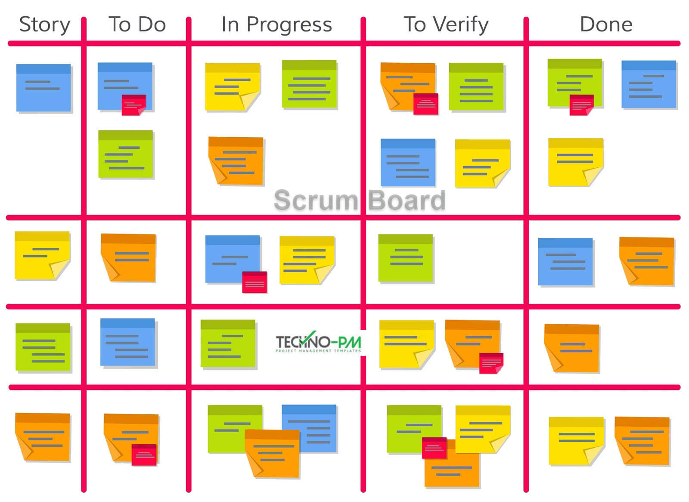

**The Scrum Rules**

* You have no Hierarchical Role.
* You are part of the team.
* The Team’s Goals are your Goals, you committed to them.
* Do whatever you can for the team to meet its goals (Forget role thinking)
* There is no individual failure-The team fails!
* There is no individual success-The team success!
* You let the team down if you are late to meetings.

**Scrum - Events**

Scrum Framework can be a sequence of events and the corresponding artifacts.

The Scrum events are time-boxed events. That means, in a project, every scrum event has a predefined maximum duration.

 The vital events of scrum are

* The Sprint
* Sprint Planning
* Daily Scrum Meetings
* The Sprint Review
* The Sprint Retrospective

**Sprint Planning**

* The Project Product owner reprioritizes the product backlog.
* The Product owner and Scrum Team to determine the work that can be completed in the next sprint.
* Work is selected from the top of the priority list by the team.
* The Product owner and the Team establish a goal for the sprint.
* The Team is expected to select only work which they can commit to finish.
* Selected items are break down into sprint backlog tasks
* Team estimation is informed by performance of previous sprints, capacity for the forthcoming sprint and relative complexity of the tasks required to deliver the Sprint Goal.

**Daily Scrum meetings**

* Daily meeting
* 15 minutes
  + Standup (to avoid too long meeting)
  + Not for problem solving
* Three questions:
  + What did you do yesterday?
  + What obstacles are in your way?
  + What will you do today?
* Offshore and Scrum
  + Part of scrum team will be located offshore
  + Offshore team will work closely with onsite teams through various SPRINT phases
* Scrum Master Responsibilities
  + Ensure self and team participates in daily scrum over teleconference
  + Ensure that burn down charts of the sprint backlog is up-to-date
  + Note impediments in his/her capability and address them
  + Ensure participation in the daily Scrum of Scrums (SoS)
  + Bring to the notice of SoS, the impediments that are not in his/her capability of solving

**Sprint Review**

• The team presents to management, customers, users and Product Owner the product increment that has been built during the Sprint

* + Sprint goal
  + Product Backlog committed
  + Product backlog completed

• The team tells story of its journey during the Sprint – honestly!

• The majority of the Sprint Review is spent with Team members presenting functionality, answering stakeholder questions regarding the presentation

• At end of presentation, stakeholders are polled, one by one to get their impressions, any desired changes, and priority of these changes.

• Product Owner discusses with Team about potential rearrangement of the Product Backlog based on the feedback.

**Sprint Review Process**

• The Team should not spend more than one hour preparing for Sprint Review.

• Functionality that isn't "Done" cannot be presented.

• Functionality should be presented and executed from development environment

• Stakeholders are free to voice any comments, observations, or criticisms regarding the increment of potential shippable product functionality

• Stakeholders can identify functionality that wasn't delivered or wasn't delivered as expected and request that such functionality be placed in the Product Backlog for prioritization.

• Stakeholders can identify any new functionality that occurs to them as they view the presentation and request that the functionality be added to the Product Backlog for prioritization.

• The Scrum Master should determine number of people who expect to attend the Sprint Review meeting and setup the meeting to accommodate them.

• At the end of Sprint Review meeting, Scrum Master announces the place and date for next Sprint Review to Product Owner and stakeholders.

**The Sprint Retrospective**

* Meeting at the end of each sprint, facilitated by Scrum Master, where the team review the sprint just completed and discusses what
* improvements they would like to make to the next sprint to make it more productive.
* Process Improvements made at the end of every sprint
* All team members identify what went well and what can be improved
  + Processes
  + Communication
  + Environment
  + Artefacts
  + Tools
  + Team dynamics
* Team devises their own solutions to problems
* Assists with team formation and bonding as conflicts identified quickly and thus can be dealt with

**Scrum - Artifacts**

The following artifacts are defined in Scrum Process Framework -

* Product Backlog
* Sprint Backlog
* Increment
* Burn-Down Chart

**SCRUM Benefits**

Team

* The teams get focused > One common goal
* Creates self-discipline, accountability & responsibility
* Faster, better Communication without barriers
* No Manager-subordinate relationship – flat structure
* Team Work, Commitment and Time & Risk Management
* There Is No Individual Failure – The Team Fails!
* There is No Individual Success –Team Success (No man of the match)!

Stakeholders

* + Higher Visibility any time
  + Ability to respond and Adapt
  + Real software code in early phase of SW life cycle
  + Better evaluation, testing, demonstration purposes.

Organization

* + Business Value - ROI

Note:

Agile process is very less documented.

Each requirement is called as story

Retrospective calls are organized by Scrum Master.

Agile is a fact-moving model

Each Sprint will take some requirements on backlog

In general Scrum team consist of 6 to 8 people.

In Each sprint will release the product increment.